Opsc7312 Research

## INTRODUCTION

In the evolving realm of personal productivity, BuddyUp emerges as a transformative tool designed to elevate time management and enhance daily routines. This research explores BuddyUp’s innovative approach to managing time effectively and fostering productivity. The document delves into the app's core functionalities, examining how features such as customizable virtual buddies, real-time image sharing, and mini-games contribute to a more engaging and productive user experience. By analyzing these aspects, we aim to provide insights into BuddyUp’s impact on time management and offer guidance for future enhancements in productivity-focused applications.

## Overview of the App

Love8 is a state-of-the-art mobile application designed to strengthen romantic relationships by providing couples with various tools to enhance communication, intimacy, and connection. The app focuses on integrating technology into daily interactions to help couples manage their relationships more effectively. (Love8, n.d.) Key features of Love8 include:

* Real-Time Location Sharing: Allows couples to share their locations, creating a sense of closeness and security. (Love8, n.d.)
* Special Day Reminders: Notifies users about significant occasions such as anniversaries and birthdays, ensuring important moments are never forgotten. (Love8, n.d.)
* Pet Interactions: Features virtual pets that couples can share and interact with, adding a playful and engaging element to their relationship. (Love8, n.d.)
* Daily Moments: Provides a platform for couples to document and share their daily experiences, building a digital record of their relationship. (Love8, n.d.)
* Milestone Recording: Helps couples track and celebrate important milestones, enhancing their sense of achievement and connection. (Love8, n.d.)

## Strengths

* User-Friendly Interface: The app is designed with an intuitive interface that is easy for users of all ages to navigate. (Love8, n.d.)
* Comprehensive Features: Offers a wide range of functionalities, from location sharing to milestone tracking, covering various aspects of a couple’s life and fostering diverse forms of connection. (Love8, n.d.)
* Multilingual Support: Supports multiple languages, making it accessible to a global audience. (Love8, n.d.)

## Weaknesses:

* Premium Features: Some essential features are available only through a subscription, which may deter users who prefer free options. (Love8, n.d.)
* Privacy Concerns: As the app handles sensitive personal information, there are potential privacy and security concerns that need to be addressed. (Love8, n.d.)

## Implementation

To develop Love8, the following steps were undertaken:

1.Development Environment Setup: The project was started in Android Studio, where a new project was created to lay the foundation for the app.

2.User Interface Design: The app's interface was designed using XML layouts and Android Studio’s Layout Editor, focusing on screens for real-time location sharing, reminders, virtual pets, daily moments, and milestones.

3. Feature Integration:

* Google Maps API was integrated for real-time location sharing.
* AlarmManager was used for managing special day reminders.
* Virtual Pets and Milestone Tracking were implemented using local or cloud databases to handle data storage and retrieval.

4. Backend Services: User data and app functionalities were managed using **Room Database** or **Firebase**, ensuring efficient data handling and synchronization.

5. Security Measures: Proper authentication and data protection strategies were put in place to safeguard user information.

6. Testing: Both unit and UI tests were conducted to ensure the app’s functionality and performance.

7. Deployment: The app was built and published on the Google Play Store, with ongoing updates and user feedback guiding future improvements.

## Overview of the Application

Snapchat, developed by Snap Inc., is a multimedia messaging application that transformed digital communication through its unique ephemeral content feature. Launched in 2011, Snapchat allows users to send photos and videos that disappear after being viewed, fostering spontaneous and authentic interactions. (Snap, Inc., n.d.) The app's core features include:

* Snaps: Photos or videos that vanish after viewing, promoting a sense of immediacy and privacy. (Snap, Inc., n.d.)
* Stories: A compilation of Snaps accessible for 24 hours, enabling users to share their daily experiences temporarily. (Snap, Inc., n.d.)
* Filters and Lenses: Augmented reality tools that add playful effects to photos and videos, enhancing user creativity and interaction. (Snap, Inc., n.d.)
* Chat: A messaging feature that supports text, voice, and video communications.
* Snap Map: Allows users to share and view locations, fostering a sense of connection with friends. (Snap, Inc., n.d.)
* Discover: A section for exploring content from publishers, celebrities, and the Snapchat community, keeping users engaged with diverse media. (Snap, Inc., n.d.)  
    
  A white logo on a yellow background

  Description automatically generated

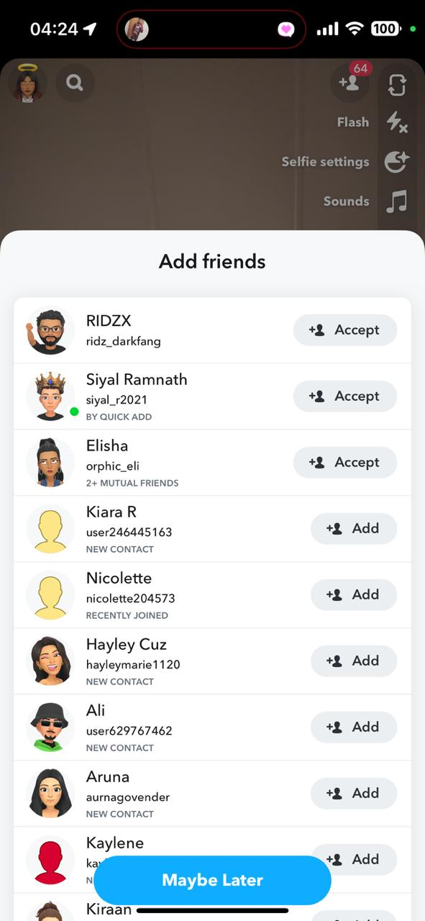

## Strengths:

* Ephemeral Messaging: The disappearing messages feature encourages spontaneous, genuine communication without the pressure of permanence. (Snap, Inc., n.d.)
* Innovative Filters: Snapchat’s unique filters and lenses enhance creativity and fun, making messaging more engaging. (Snap, Inc., n.d.)
* User Engagement: Features such as Snap Map and Discover keep users connected and entertained with a variety of content. (Snap, Inc., n.d.)

## Weaknesses:

* Privacy Concerns: The temporary nature of messages might lead to a false sense of security, raising potential privacy issues. (Snap, Inc., n.d.)
* Addiction and Mental Health: The app's design can be addictive, with the pursuit of validation impacting users' mental well-being. (Snap, Inc., n.d.)
* Complex Interface: New users may find the app’s interface challenging and confusing to navigate. (Snap, Inc., n.d.)

## Implementation

Snapchat was developed using a robust tech stack to support its multimedia capabilities and real-time interactions:

1. Backend Infrastructure: The app leverages a combination of custom-built servers and cloud services to handle the high volume of media and user interactions. This includes the use of content delivery networks (CDNs) to efficiently distribute images and videos. (Snap, Inc., n.d.)
2. Frontend Development: Snapchat’s frontend is built with a focus on performance and user experience. The app uses native development tools for iOS and Android to ensure smooth and responsive interfaces. (Snap, Inc., n.d.)
3. Augmented Reality: Filters and lenses are powered by advanced computer vision and augmented reality technologies, allowing real-time image processing and effects. (Snap, Inc., n.d.)
4. Real-Time Communication: Snapchat employs real-time messaging protocols and server push technologies to deliver messages and updates instantaneously. (Snap, Inc., n.d.)
5. Security Measures: The app integrates encryption and secure authentication methods to protect user data and privacy. (Snap, Inc., n.d.)



## Overview of the Application

Tinder is a widely popular dating application that has transformed online dating with its user-friendly swipe-based matching mechanism. Launched in 2012 by Tinder Inc., the app helps users form connections based on shared interests and geographic proximity. (Tinder, Inc., n.d.) Key features include:

* Swiping Mechanism: Users interact with profiles by swiping right to like or left to pass. A mutual right swipe results in a match, enabling users to start chatting. (Tinder, Inc., n.d.)
* Profiles: Users create profiles with photos, a bio, and personal interests to attract potential matches. (Tinder, Inc., n.d.)
* Messaging: Once matched, users can communicate via the app’s messaging system to get to know each other. (Tinder, Inc., n.d.)
* Premium Subscriptions: Tinder offers several subscription plans—Tinder Plus, Tinder Gold, and Tinder Platinum—providing benefits like unlimited swipes, location changes with Passport, and profile promotion with Boost. (Tinder, Inc., n.d.)
* Safety Features: Includes photo verification and in-app security tips to enhance user protection. (Tinder, Inc., n.d.)
* Events and Activities: Occasionally organizes events and activities to offer additional connection opportunities. (Tinder, Inc., n.d.)



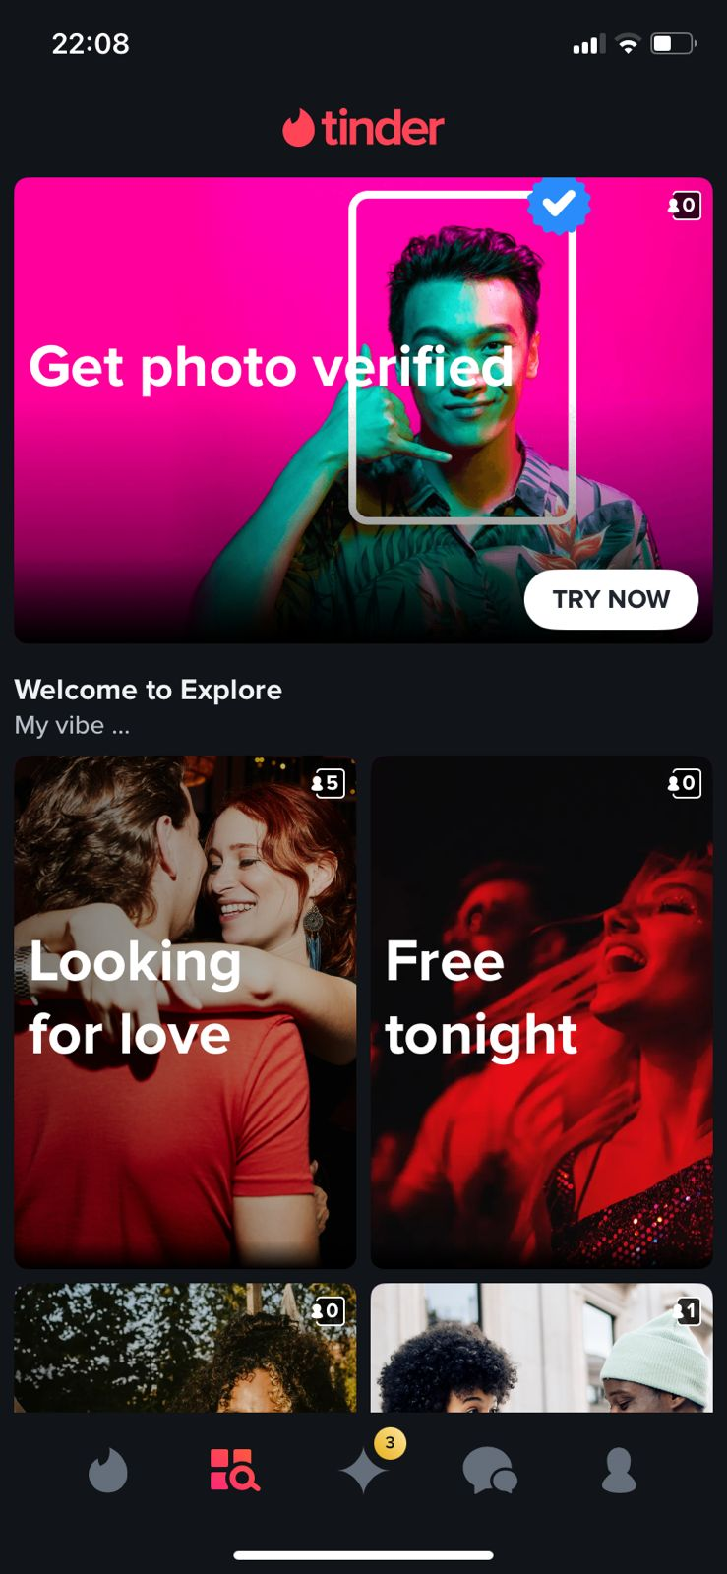  
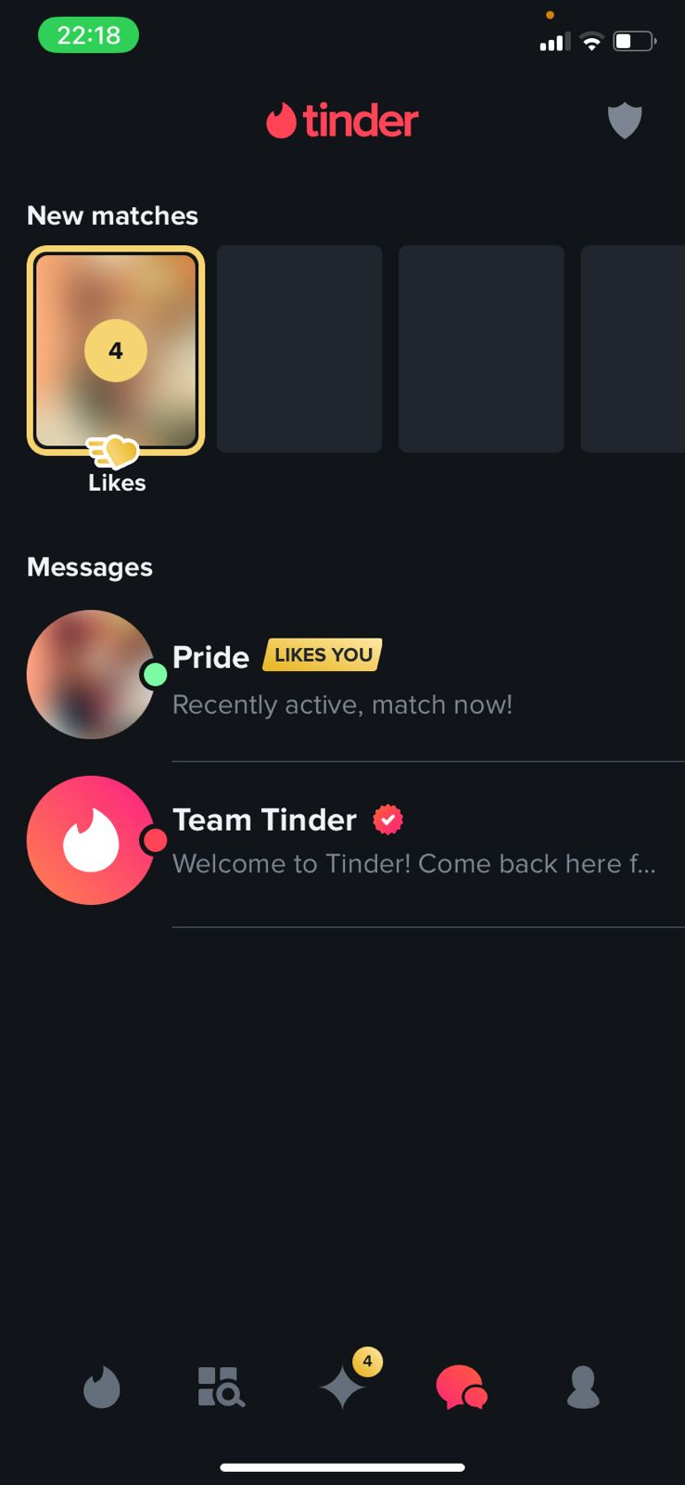

## Strengths:

* Large User Base: Tinder's extensive global reach increases the likelihood of finding compatible matches. (Tinder, Inc., n.d.)
* Simple Interface: The swipe-based interaction is intuitive and easy to use, making it accessible to a wide audience. (Tinder, Inc., n.d.)
* Premium Features: Subscriptions offer valuable enhancements, such as unlimited swipes and profile boosts, which can significantly improve the dating experience. (Tinder, Inc., n.d.)

## Weaknesses:

* Fake Profiles: The presence of fake profiles and scams can be frustrating and diminish the user experience. (Tinder, Inc., n.d.)
* Superficial Matches: The swipe mechanism may encourage superficial judgments based on photos rather than fostering deeper connections. (Tinder, Inc., n.d.)
* Privacy Concerns: The app collects substantial personal data, which may raise privacy issues for some users. (Tinder, Inc., n.d.)

## Implementation

The development of Tinder involved several key technological and design elements:

1. Backend Infrastructure: Tinder uses a combination of cloud services and custom-built servers to handle the large volume of user data and interactions. This includes scalable databases and real-time data processing systems to support the app's extensive user base. (Tinder, Inc., n.d.)
2. Frontend Development: The app is developed using native technologies for iOS and Android to ensure a smooth and responsive user experience. This includes implementing swipe gestures and interactive elements that are central to the app's functionality. (Tinder, Inc., n.d.)
3. Matching Algorithm: Tinder employs algorithms to match users based on their swiping behavior, location, and preferences. This involves machine learning techniques to enhance match accuracy and user satisfaction. (Tinder, Inc., n.d.)
4. Messaging System: Utilizes real-time messaging protocols to facilitate instant communication between matched users, ensuring seamless and timely interactions. (Tinder, Inc., n.d.)
5. Security Measures: Incorporates encryption and secure authentication methods to protect user data and privacy. Features like photo verification help enhance user trust and safety. (Tinder, Inc., n.d.)

|  |  |  |  |
| --- | --- | --- | --- |
| Feature | Love8 | Snapchat | Tinder |
| Primary Purpose | Enhancing romantic relationships | Multimedia messaging and social media | Online dating and matchmaking |
| Core Features | Real-time location sharing, special day reminders, virtual pets, daily moments, milestone tracking | Ephemeral Snaps, Stories, Filters, Lenses, Snap Map, Discover, Spotlight | Swipe-based matching, profiles, messaging, premium subscriptions (Plus, Gold, Platinum) |
| Target Audience | Couples | General public, particularly younger demographics | Individuals seeking romantic connections |
| Content Longevity | Persistent shared moments and milestones | Content disappears after viewing | Persistent profiles and messages |
| Privacy and Security | Focus on secure sharing between couples | Ephemeral messaging with privacy controls but potential risks with disappearing content | Profiles with safety features like photo verification, but issues with fake profiles |
| User Interaction | Private interactions between couples | Public and private interactions, with content sharing | Private interactions between matched users |
| Geolocation Features | Real-time location sharing for couples | Snap Map for location sharing among friends | Location-based matching with the option to change location via premium subscription (Passport) |
| Content Creation Tools | Personalized stories and milestone tracking | Creative filters, lenses, and AR effects | Profile customization with photos and bios |
| Daily Engagement | Daily check-ins and shared experiences | Daily Snaps and Stories, Discover content | Daily swiping, matching, and messaging |
| Platform Compatibility | iOS and Android | iOS, Android, Web | iOS, Android, Web |

**BuddyUp** focuses on enhancing social connections and virtual companionship with features like customizable avatars and real-time image sharing. It’s designed for general users seeking interactive and entertaining ways to connect.

**Love8** aims to deepen romantic relationships by providing tools for shared experiences and relationship management. It offers features like real-time location sharing and milestone tracking tailored for couples.

**Snapchat** revolutionizes multimedia messaging with its ephemeral content and creative features. It’s popular among younger users for its spontaneous and creative communication tools, including filters and lenses.  
  
  
How to implement Love8 in android studios:

To implement Love8, we'll start by setting up our development environment in Android Studio and creating a new project. We'll design the user interface using XML layouts and Android Studio’s Layout Editor, focusing on screens for location sharing, reminders, virtual pets, daily moments, and milestones. Core features will include integrating Google Maps API for real-time location sharing, using AlarmManager for special day reminders, and implementing virtual pets and milestone tracking with local or cloud databases. We'll manage user data and backend services using Room Database or Firebase and ensure security through proper authentication and data protection. Testing will involve unit and UI tests to ensure functionality, and we'll finalize the app by building and publishing it on the Google Play Store. Regular updates and user feedback will guide further improvements.

## How to implement Snapchat in android studios:

To implement a Snapchat-like app in Android Studio, we'll start by setting up the development environment and creating a new project. We'll design the user interface using XML layouts for key screens, including the camera, chat, and Stories. Core features will include integrating CameraX for capturing media, using Firebase for real-time messaging and data storage, and implementing filters with augmented reality tools. We'll manage user authentication with Firebase Authentication and ensure data security. Testing will involve unit and UI tests, and we'll build and publish the app on the Google Play Store. Post-launch, we'll monitor performance and user feedback to make continuous improvements.

## How to implement Tinder in android studios:

To implement a Tinder-like app in Android Studio, we’ll start by setting up the development environment and creating a new project. We’ll design user interfaces for profile management, swiping, and messaging using XML layouts and RecyclerView for swipeable profiles. Key features include implementing swipe gestures for matching, integrating Firebase for real-time messaging and profile storage, and adding premium features with in-app purchases. User authentication will be handled through Firebase, and we'll ensure data security and privacy. Testing will involve unit and UI tests, and we’ll build and publish the app on the Google Play Store. Post-launch, we’ll monitor performance and gather user feedback for continuous improvements.

## Best features :

Love8

* Real-time location sharing: Enhances the sense of closeness by allowing couples to see each other's locations.
* Special day reminders: Keeps users informed about important occasions like anniversaries and birthdays.
* Daily moments: Allows couples to share and document their daily experiences, creating a digital record of their relationship.
* Milestone tracking: Helps users celebrate and remember significant milestones in their relationship.

Snapchat

* Ephemeral messaging: Sends photos and videos that disappear after being viewed, promoting spontaneous and authentic communication.
* Filters and lenses: Offers a variety of augmented reality filters and lenses to add creative effects to photos and videos.
* Snap Map: Allows users to share and view each other's locations on a map.
* Stories: Lets users group Snaps into a Story that remains visible for 24 hours, encouraging regular engagement and sharing.

Tinder

* Swipe mechanism: Simplifies the process of finding matches with an intuitive swipe-based interface.
* Profile customization: Allows users to create and personalize profiles with photos, bios, and interests.
* Messaging system: Provides a robust platform for communication between matched users, including text, voice, and video options.
* Premium features: Offers additional benefits such as unlimited swipes and profile boosts through various subscription plans.

## LIST OF FEATURES TO INCLUDE IN BUDDYUP:

Swiping Feature:

* Tinder: Swipe-based mechanism for finding matches.

Chat Feature:

* Snapchat: Supports text, voice, and video communication.
* Tinder: Messaging available after matching.
* Love8: Allows communication through daily moments and special features.

Customizable Virtual Buddy:

* Snapchat: Customization through filters and lenses.
* Love8: Customization with virtual pets.

Real-Time Image Sharing:

* + Snapchat: Images shared in real-time with content disappearing after viewing.

Mini-Games:

* + Snapchat: Mini-games in the Discover section.

User Authentication:

* + Snapchat: Includes user registration and login.
  + Tinder: Offers in-app authentication.
  + Love8: Includes user login but not specified for biometric options.

Real-Time Notifications:

* + Snapchat: Push notifications for updates.
  + Tinder: Push notifications for matches and messages.
  + Love8: Notifications for special days and moments.

Offline Functionality with Sync:

* Snapchat: Limited offline functionality.
* Tinder: Limited offline functionality.
* Love8: Does not specify offline features

CONCLUSION  
  
In conclusion, each app—Snapchat, Tinder, and Love8—offers unique features that cater to different aspects of user interaction and engagement. Snapchat excels in ephemeral content, real-time image sharing, and a rich set of creative tools, while Tinder provides a straightforward and effective swipe-based matching system, enhancing the dating experience. Love8, on the other hand, focuses on enhancing romantic relationships with customizable virtual pets and special features for maintaining connection and intimacy.

By understanding the distinct functionalities of these apps, we can leverage their strengths to inform the development of BuddyUp. Incorporating elements such as real-time notifications, customizable features, and engaging mini-games from these existing applications will help create a robust and engaging platform for users. Integrating these innovative features while addressing their limitations can lead to a well-rounded and compelling app experience, setting BuddyUp apart in the competitive landscape of social and relationship-based applications.  
  
  
References

**Love8**: Love8. (n.d.). Retrieved from <https://www.love8.ltd/>.

**Snapchat**: Snap Inc. (n.d.). Snapchat. Retrieved from [https://www.snapchat.com](https://www.snapchat.com/).

**Tinder**: Tinder, Inc. (n.d.). Tinder. Retrieved from [https://www.tinder.com](https://www.tinder.com/).

AltexSoft, 2023. *Functional and Nonfunctional Requirements Specification and Types*. [online] Available at: <https://www.altexsoft.com/blog/functional-and-non-functional-requirements-specification-and-types/> [Accessed 5 August 2024].

IIDE, 2024. *Elaborated SWOT Analysis of Snapchat*. [online] Available at: <https://iide.co/case-studies/swot-analysis-of-snapchat/> [Accessed 5 August 2024].